Implementation of Space Vector Modulation in a 3-φ VSI-type Stand Alone Inverter

Muhammad Uzair

Tampere University of Technology
A-163, Block-C, Gulshan-e-Jamal
Karachi, Sindh, Pakistan.
uzair_ishtiaque@yahoo.com

Abstract

From the last two decade or so, the consumption of renewable energy sources has increased enormously which leads to increase the demand of power electronics converter. Here, the purpose is to generate AC signal of varying amplitude and frequency from a constant stiff DC voltage source which can be used for motor drive application. If the source is not stiff, a large capacitor is placed between the source and power stage of the inverter. Nowadays, the pure sine wave inverter has gain more popularity which utilize either carrier based PWM or Space vector PWM (SVPWM).The SVPWM is chosen because of better utilization of DC bus voltage and ease of digitization for many DSP controllers as well as reduction in total harmonic distortion which makes the output more efficient. On the contrary, it is complex to implement. This paper describes the concept, theory and implementation of three level SVPWM and DC neutral point potential control scheme using MATLAB/Simulink environment.

Keywords-component: SVPWM, VSI, NPC, stationary vectors, THD, DC bus utilization.
I. Introduction

Energy generated from renewable energy sources such as wind, wave and photovoltaic are heavily dependent on power converters as they are not capable of producing such amount of power that the electrical grid withstand with it. In order to cope with this problem, the intermediate device need to be incorporated between the powers obtained from renewable sources and electrical grid. Here, the role of power converters comes into action. Inverters are made of power switches which need to be switched at a particular interval to get the proper output level in terms of desired voltage amplitude and frequency. This is done by means of PWM technique. The carrier based PWM doesn’t properly employ DC bus utilization and harmonics [1] while SVPMW do so. By comparative analysis between 2-level and 3-level inverter, 3-level has more power switches which leads to the switching of large number of space vectors and makes it complex to implement. The role of multilevel converters appear when THD has become the most significant problem which needs to be mitigate in order to transfer maximum amount of power. The concept of space vector emerged from the theory of electrical machines where the associated flux which rotates in the air-gap causes a production of mmf. This revolving mmf is an example of space vector.

II. Voltage Source Inverter

There are varieties of multilevel converters available like Cascaded H-Bridge inverter, flying capacitor inverter. Each type has its own advantage depending upon the application but Neutral point converter has gained more popularity and attention as far as this paper is concerned. It is also named as ‘Diode clamped inverter’ because of the fact that diode are used to clamped the potential of DC midpoint ‘o’ to switching element. A simple configuration of three levels NPC is shown in fig.1. In general, for n-level converter requires (n-1) capacitors, 2(n-1) power switches per phase and 2(n-2) clamping diodes [5]. These power switches are capable of delivering either +$\frac{Vdc}{2}$ , 0 V_{dc} and - $\frac{Vdc}{2}.$ Table I shows the status of power switches at different pole voltages.

TABLE I
STATUS OF SWITCHES

Pole Voltage | S_{A1} | S_{A2} | S_{A1}’ | S_{A2}’
$+\frac{1}{2}$Vdc | ON | ON | OFF | OFF
0 Vdc | OFF | ON | ON | OFF
$-\frac{1}{2}$Vdc | OFF | OFF | ON | ON

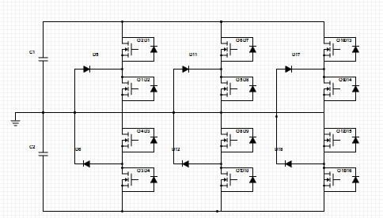

Fig.1 Three Level Neutral Point Clamped inverter

III. SVPWM algorithm

It comprises of different stationary vectors having different magnitude and angles. Each switching state defines different output state which is obtained by combination of these vectors. The bunch of these vectors combine together to constitute space vector diagram. The space vector diagram for the three level inverter is shown in fig.2. It indicates the position of each vector in space with respect to its magnitude and angle. The reference vector rotates with constant switching frequency within the hexagon. At each switching instant some complex mathematical calculation is performed to get PWM pulses. When the reference vector lies within the hexagon the inverter will operate in under-modulation region provides a better quality at the output terminals. The over-modulation mode occurs when reference vector lies outside the premises of hexagon. For three level inverter the modulation index is,
m = $\sqrt{3}\left({Vref}/{Vdc}\right)$

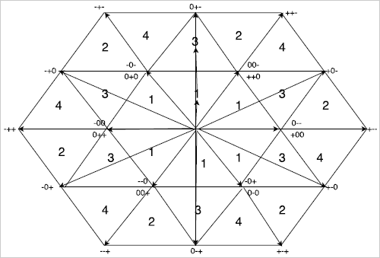

Fig.2 Space Vector Diagram

The pole voltage at each leg is either +$\frac{V_{dc}}{2}$ , 0 V_{dc} & - $\frac{Vdc}{2}$ and three legs available in NPC which makes 3³=27 switching vectors. The space vectors are categorized as large vectors having amplitude of V_{dc}, medium vectors having amplitude of $\frac{\sqrt{3}}{2}$V_{dc}, small vectors having amplitude of $\frac{1}{2}$V_{dc} and null vector or zero vectors having amplitude of 0V_{dc}. The space vector diagram consists of 6 sectors and each sector is further decomposed into 4 regions which constitutes a total of 6*4=24 regions in a complete hexagon. For the competitive study, the analysis will be done on one sector and the procedure will remain same for the rest.

In order to implement this algorithm three phase quantities must be converted into two phase quantities (α and β) which can be done by means of Clark’s transformation. These two part combine together to form a plane.

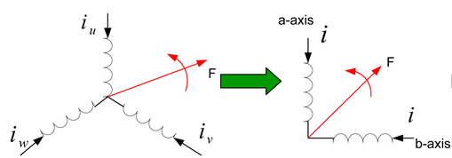

Fig.3 Pictorial view of Clark’s Transformation [3]

The Clark’ transformation provides the relationship between the abc reference frame and stationary reference frame (αβ0) [2]. This relationship is given as,
$\left[\begin{matrix}Vα \\ Vβ\end{matrix}\right]$ = $\frac{2}{3}\left[\begin{matrix}1 & \frac{-1}{2} & \frac{-1}{2} \\ 0 & \frac{-\sqrt{3}}{2} & \frac{-\sqrt{3}}{2} \\ \frac{1}{2} & \frac{1}{2} & \frac{1}{2}\end{matrix}\right]\left[\begin{matrix}Va \\ Vb \\ Vc\end{matrix}\right]$
The position of stationary vector in space is dependent on the magnitude of vector as well as its direction by means of angle which can be calculated as,
V_{ref =} $\sqrt{{V_{α}}^{2}+}{V_{β}}^{2}$
θ = $\tan^{-1}\left(\frac{V_{β}}{V_{α}}\right)$

Sector Selection

The space vector diagram is divided into 6 sectors and each sector comprise of 60º which makes the reference vector to rotate in entire 360º orbit. Once the value of ‘θ’ is known the sector can be identified easily using the strategy given below,

If 0º≤θ<60º the sector is I.
If 60º≤θ <120º the sector is II.
If 120º≤θ <180º the sector is III.
If 180º≤θ <240º the sector is IV.
If 240º≤θ <300º the sector is V.
If 300º≤θ <360º the sector is VI.

Region Identification

The region selection is done by splitting the reference vector into its coordinate i.e. α and β as shown in fig.4. Here, $Xn$ = reference vector.
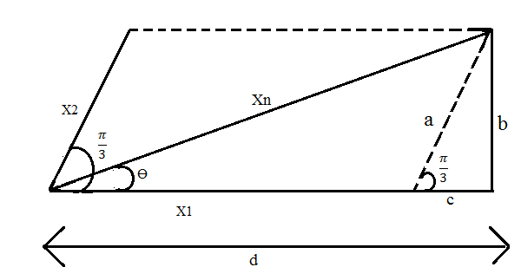
Fig.4 Reference vector and its corresponding coordinate

Refer fig.4 for solving X₁ and X_{2,}
$\sin\left(π/3\right)$ = $b/a$ → a=$b/{\sin\left(π/3\right)}$
Refer fig.4, b=$XnSinθ$ and a=X₂
X₂= ${XnSinθ}/{\sin\left(π/3\right)}$ → X₂= $\left(2/{\sqrt{3}}\right) XnSinθ$
d= X₁ + c
$Xn\cos{θ}$ = X₁ + c
X₁ = $Xn\cos{θ}$ – c (1)
$\cos\left(π/3\right)$ = $c/a$ → c = a$\left(1/2\right)$
Refer fig.4, a= X₂
c =$\left(2/{\sqrt{3}}\right)XnSinθ\left(1/2\right)$→ c = $\left({XnSinθ}/{\sqrt{3}}\right)$ (2)
X₁= $Xn\cos{θ}$ $-$ $\left({XnSinθ}/{\sqrt{3}}\right)$
X₁= $Xn\left(CosƟ- \left({Sinθ}/{\sqrt{3}}\right)\right)$ (3)
- If X₁<0.5V_{DC}, X₂<0.5V_{DC} and (X₁+X₂) <0.5V_{DC} the reference vector lies in region I.
- If X₁>0.5V_{DC} the reference vector lies in region II.
- If X₁<0.5V_{DC}, X₂<0.5V_{DC} and (X₁+X₂) >0.5V_{DC} the reference vector lies in region III.
- If X₂>0.5V_{DC} the reference vector lies in region IV.

Dwell Time Calculation

Once the region and sector is identified the next step is to calculate the on-time duration of three nearest vector. For the sake of simplicity, the volt-second balance in region I give,
V₂*T_{a} + V₁*T_{b} + V₃*T_{c} = V_{ref}*T_{s} (4)
where,
V₁= 0V_{dc}$e^{j0}$ V₂= $\frac{1}{3}$ V_{dc}$e^{j0}$ V₃= $\frac{1}{3}$ V_{dc}$e^{j\frac{π}{3}}$
Resolve equation. (4) into its real and imaginary components gives,
$\left(1/3\right)$T_{a}+0T_{b}+$\left(1/6\right)$T_{c}=$\left({Vref}/{Vdc}\right)cos{Ɵ}$T_{s} (5)
0Ta+0T_{b}+$\left({\sqrt{3}}/6\right)$T_{c}=$\left({Vref}/{Vdc}\right) \sin{Ɵ}$T_{s} (6)
T_{a}+T_{b}+T_{c}= T_{s} (7)
By simultaneously solving these equations gives,
Ta = Ts$\left[2m\sin\left(\frac{π}{3}- Ɵ\right)\right]$
Tb = Ts$\left[1-2m\sin\left(\frac{π}{3}+Ɵ\right)\right]$
T_{c} = 2m_{a}$\sin{Ɵ}$T_{s}
The dwell time for the remaining regions of sector I are given in Table II.

TABLE II
DWELL TIME OF SECTOR I

Region | Ta | Tb | Tc
1 | Ts$\left[2m\sin\left(\frac{π}{3}- Ɵ\right)\right]$ | Ts$\left[1-2m\sin\left(\frac{π}{3}+Ɵ\right)\right]$ | 2m$\sin{Ɵ}$T_{s}
2 | Ts$\left[2-2m\sin\left(\frac{π}{3}+Ɵ\right)\right]$ | 2m$\sin{Ɵ}$T_{s} | Ts$\left[2m\sin\left(\frac{π}{3}- Ɵ\right)-1\right]$
3 | $\left(1- 2m\sin{Ɵ}\right)$T_{s} | Ts$\left[2m\sin\left(\frac{π}{3}+ Ɵ\right)- 1\right]$ | Ts$\left[1-2m\sin\left(\frac{π}{3}-Ɵ\right)\right]$
4 | 2m$\left(\sin{Ɵ}- 1\right)$T_{s} | Ts$\left[2m\sin\left(\frac{π}{3}- Ɵ\right)\right]$ | Ts$\left[2-2m\sin\left(\frac{π}{3}+Ɵ\right)\right]$

Switching Pattern

In order to mitigate the problem of harmonics only one phase is switched at a time while the remaining phase keeps at their previous state. For this purpose, the available switching schemes are 7-segment, 9-segment and 13-segments switching schemes.
For region I: --- → 0-- → 00- → 000 → +00 → ++0 → +++ → ++0 → +00 → 000 → 00- → 0-- → ---
For region II: 0-- → +-- → +0- → +00 → +0- → +-- → 0--
For region III: 0-- → 00- → +0- → +00 → ++0 → +00 → +0- → 00- → 0—
For region IV: 00- → +0- → ++- → ++0 → ++- → +0-→00-

IV. Symmetrical PWM Generator

Once the switching sequence is calculated, the next objective is to calculate the duty cycle of the power switches. The bottom two switches of each leg of the inverter are connected in complementary fashion. So, there is no need to calculate the duty cycle of the bottom two switches. The switching sequence of region I of sector I is given in Fig.5, each phase has 3 different voltage levels which require 2 PWM generators [4]. The duty ratio of top two switches of each leg of the inverter is given in Table III.

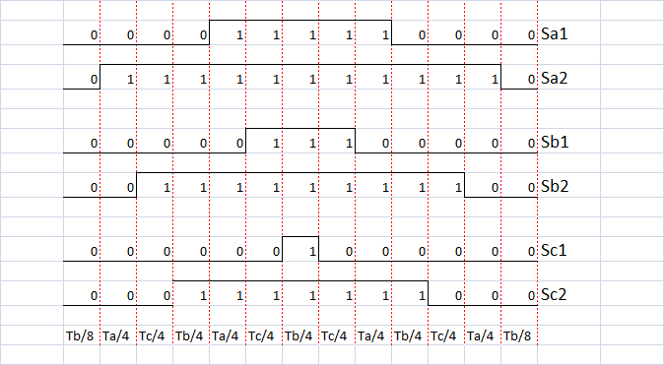

Fig.5 Gate pulses of upper two switches of each phase leg for region I of sector I.

TABLE III
DUTY RATIO OF TOP TWO UPPER SWITCHES

Switch | Duty Ratio
S_{A1} | $$\frac{2Ta+Tb+2Tc}{4Ts}$$
S_{A2} | $$\frac{4Ta+3Tb+4Tc}{4Ts}$$
S_{B1} | $$\frac{Tb+2Tc}{4Ts}$$
S_{B2} | $$\frac{2Ta+3Tb+4Tc}{4Ts}$$
S_{C1} | $$\frac{Tb}{4Ts}$$
S_{C2} | $$\frac{2Ta+3Tb+2Tc}{4Ts}$$

V. Computer Model

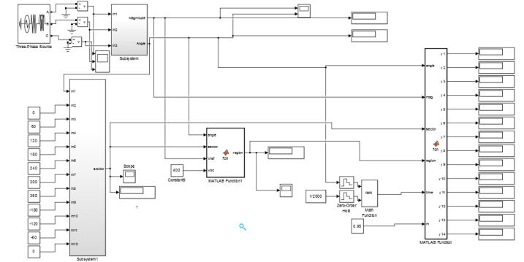

Fig.6 Sector and region selection block & PWM generator

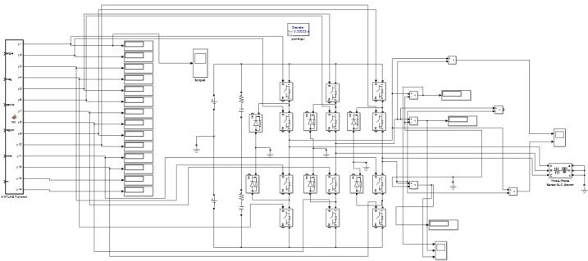

Fig.7 Power Stage of the inverter

Fig.6 and Fig.7 shows the model of 3-level SVPWM with 3-φ star connected load. In fig.6 Subsystem block is the implementation of Clark’s Transformation to calculate magnitude and angle of reference vector. Subsystem 1 is the implementation of sector determination. MATLAB Function1 block incorporates the value of X₁, X₂ and (X₁+X₂) to calculate the region. The dwell time calculation Ta, Tb and Tc are calculated in MATLAB Function block which further generates the gate pulses and drives the 3-level NPC inverter.

VI. Simulations & Results

Simulation results for the implementation of 3-φ, 3-level SVPWM is shown in Fig.8-11 respectively. These simulation runs with the following parameters, f₁=50Hz, V_{dc}= 400V, fs= 2 kHz. R_{L}=10Ω, L_{load}=7mH and m=0.95 and Ts=1/2000sec.

Fig.8 PWM Pulses

Fig.9 Line-to-Neutral voltage

Fig.10 Line-to-Line voltage

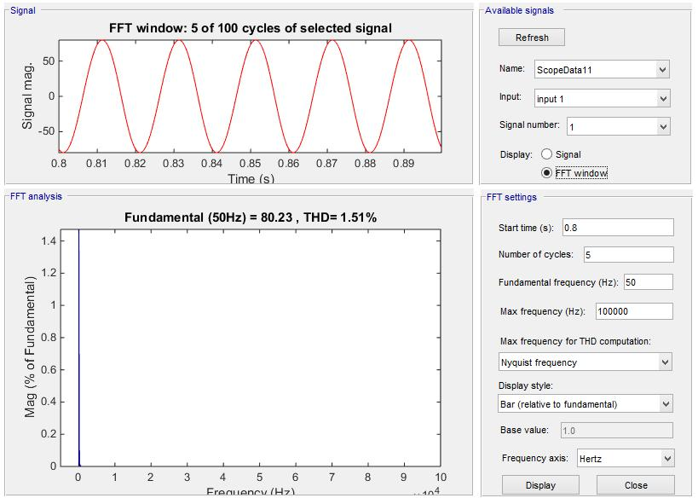

Fig.11 Harmonic analysis of line current (R-φ)

VII. Conclusion
In this paper the algorithm for the three phase three level SVPWM is presented in MATLAB/Simulink environment with detailed study of each block. The brief study shows the reduction of THD comparatively to two-level inverter. Refer [6] shows the harmonic spectrum of 2-level inverter. The FFT analysis has been performed to study the behavior of different harmonics component. The comparative study between SPWM and SVPWM shows the better performance of SVPWM by means of better utilization of DC bus which leads to increase in fundamental component up to some extent.

References

- S.Maniavannan, S.Veerakumar, P. Karuppusamy, A. Nandhamukar, “Study and Analysis of Three Phase Voltage Source Inverter Fed Induction Motor Drive in Various Pulse Width Modulation Techniques” volume No.3 Issue No.8, 1st Aug 2014, pp: 1111-1114.
- S.Maniavannan, S.Veerakumar, P. Karuppusamy, A. Nandhamukar, “Performance Analysis of Three Phase Voltage Source Inverter fed Induction Motor Drive with possible Switching Sequence Execution in SVPWM”,Vol.3, Issue 6, June 2014.
- Dr.Yashvant Jani and Graeme Clark, “MCU with FPU allows advanced Motor Control Solutions”, Renesas Electronics America, Renesas Electronics Europe, 24 April, 2014.
- Haibing Hu, Wenxi Yao and Zhengyu Lu, “Design and Implementation of Three-Level Space Vector PWM IP Core for FPGA’s” IEEE Transactions on Power Electronics, VOL.22, No.6, November 2007.
- Weixing Feng, “Space Vector Modulation for Three Level Neutral Point Clamped Converter”, M.S Thesis, Dept. Elect. And Comp. Eng. Ryerson Univ., Toronto, Canada, 2004.
- P. Tripura, Y.S. Kishore Babu, Y.R. Tagore, “Space Vector Pulse Width Modulation for Two-Level Voltage Source Inverter”, ACEEE Int. J. on Control System and instrumentation, Vol. 02, No. 03, October 2011.

